**Calculated Fields and Time Series Analysis in Tableau**

**Step 1:**

Download the dataset from repository.

Import the dataset in Tableau. To import the data, you need to click on Microsoft Excel on the home screen of Tableau and select the file to be imported.

Under sheets you will find the names of three sheets. If you look at your dataset in excel, you will find those three sheets there. Now you can choose the sheet on which you want to create visualization. You can choose more than one sheet too. In the case of selecting more than one sheet, a join will be created based on the columns in the sheets.

For this exercise, we will select “Orders” sheet. To select the sheet, drag it to the area labelled with text “Drag sheets here”.



Click on Sheet 1 in bottom left corner.

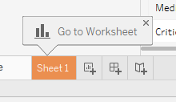

This will create a new sheet for you to work upon.

**Step 1:**

The management of the store wants to invest $500K in the product sub-category under all product category which is producing highest profit percentage i.e. less cost price and maximum return.

We will try to find out the appropriate product sub categories for the management.

You can see the dimensions and measures on the right side of the sheet. You can find sales and profit measures under the “Measures” section.

Drag category and sub-category to rows and profit to columns.

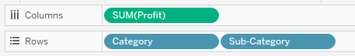

You will get a bar chart.

If you get a horizontal bar chart, click on show-me and select side-by-side bars. If you get sub-category in color mark, remove it from there. We will apply colors later.

Now click on the small sort icon on the profit axis to sort the bars from highest to lowest.

Drag profit to label and color.

What do you think? Are we done and can say that we have found the highest profit-making sub-category of product under each category???

The answer is **NO**. We don’t know yet. We know the highest profit-making sub-category, but which sub-category has the highest profit percentage, we are not able to answer that.

Look at the dataset. Do we have any column for profit percent?

Again, the answer is **NO.**

We need to create one. We know that profit percentage = (profit/cost price) * 100. We don’t have cost price either, but we do have sales and profit and we know that cost price = sales – profit. So, our profit percentage formula will look like

Profit percentage = (profit/ (sales - profit))*100.

So, lets create a calculated field.

To do so, right-click anywhere in the “Measures” pane. A popup will appear. Click on “Create Calculated Field”.

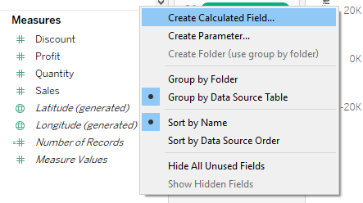

In the window which appears next put the following formula:

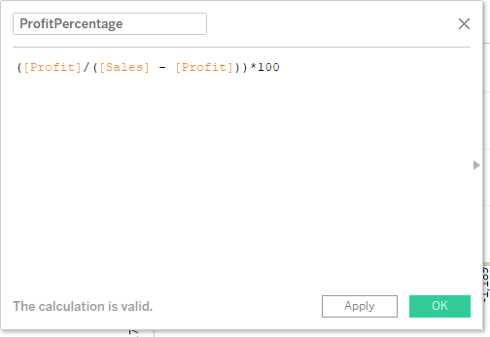

Click on apply and the n OK.

Under Measures, you will find a new field named ProfitPercentage.

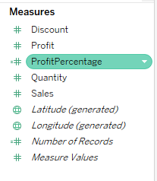

Now, right click on the sheet name at the bottom left corner, and choose duplicate.

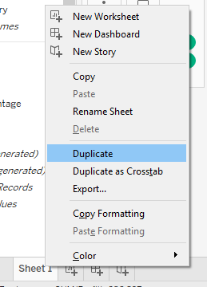

It will make a copy of the sheet.



Now, drag profitpercentage to rows. Change the aggregation to average.

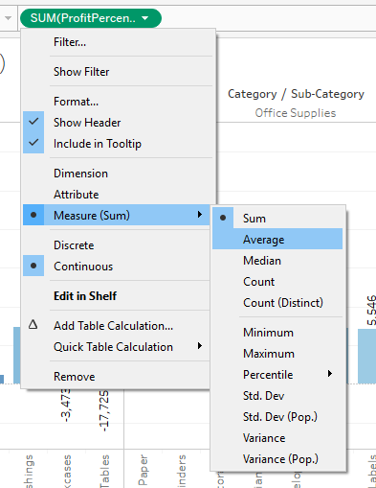

Press Ctl button and hold the green pill of AVG(ProfitPercentage) which you have put in rows. Drag it to label and color.

Sort the bars from highest to lowest.

Is there any change in your answer from first sheet and second sheet??

Now click on label. And change the font to 10 and make it bold.

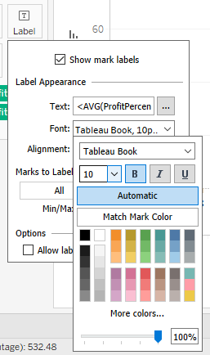

Now click on color. Go to border and make it black.

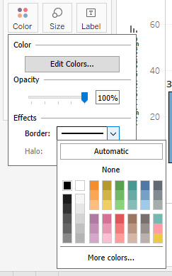

Do these two changes for both the sheets.

You need to give meaningful names to both the sheets.

1. Make a table which will have product category, prediction based on first sheet and answers based on second sheet.

**Step 2:**

Click on new worksheet icon.

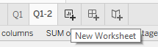

Drag profit to rows and order date to column.

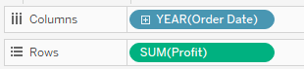

You will find that the default level of granularity of order date is YEAR. We will change it to month. Click the small downward triangle and select month.

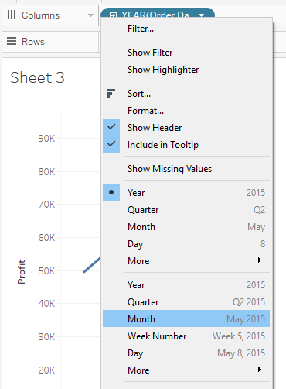

Now we have a time series in the form of line.

Drag category to color. You can see that now we have three separate lines for each product category. One thing to notice is that if you select on any of the options in the color legend, you will have the line corresponding to that legend highlighted in the sheet. This will help you make separate analysis of a category as compared to others.

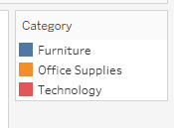

If you want to have all the points on the line, click on color. Under Effects go to Markers and select All.

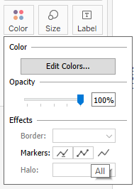

The above step is not required. Its only for your information.

Give a meaningful name to your sheet.

Now click on show me and then on area chart.

Did you find any difference in the axis?

The area chart is different from line charts. In area chart the measure value are stacked on top of each other whereas in lien chart the lines are independent.

Drag ship mode to filters. On the window which appears, select All, then Apply and then OK.

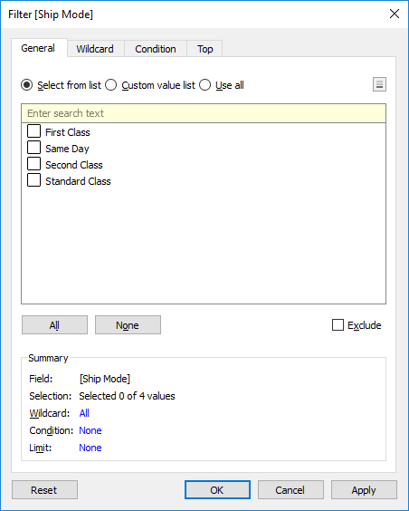

Right click on filter and then show filter.

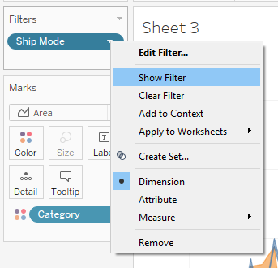

You will find that the filter will appear on the right side. By clicking on the small down arrow, you can see a number of options to modify your filter. We will not use them here, as it is not required in this visualization, but you should know this.

Select only standard class from the filter.